A breakdown of the structural design:

* **User Interface (UI):**
  + Authentication of Users which consists of: Username and password input fields.

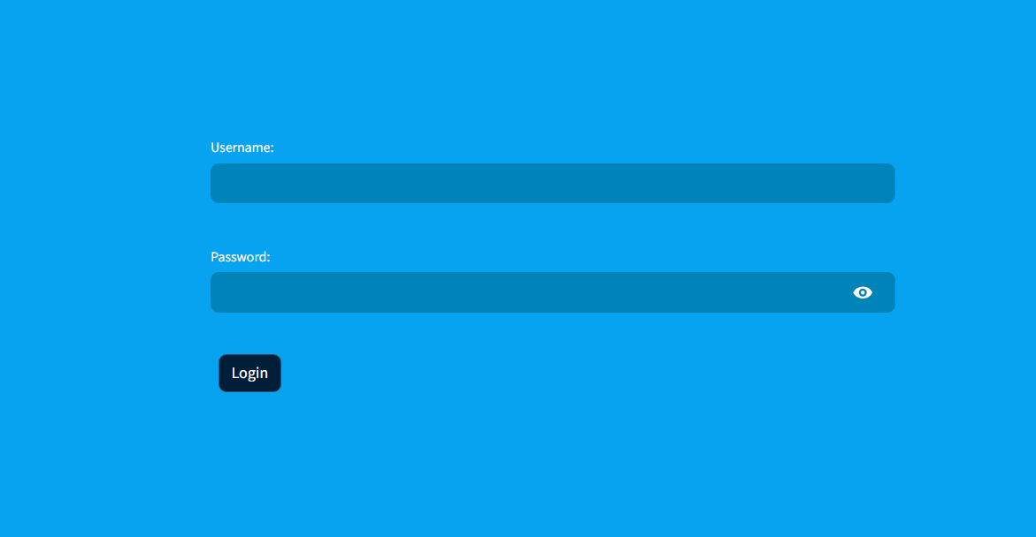

* 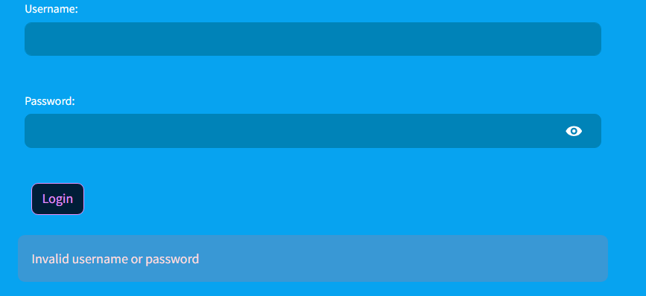Error message display for invalid credential if the user has input wrong credential
  + Select box to choose between Explore and Predict pages which is used to view either the Explore page which consists of the Bar graphs or the Predict page is consists of the UI where the user inputs value to make the prediction

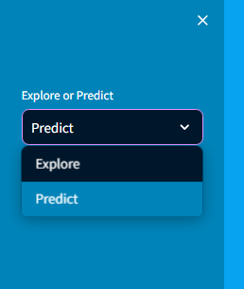

* The UI is the interface through which users interact with. It can be a web-based interface.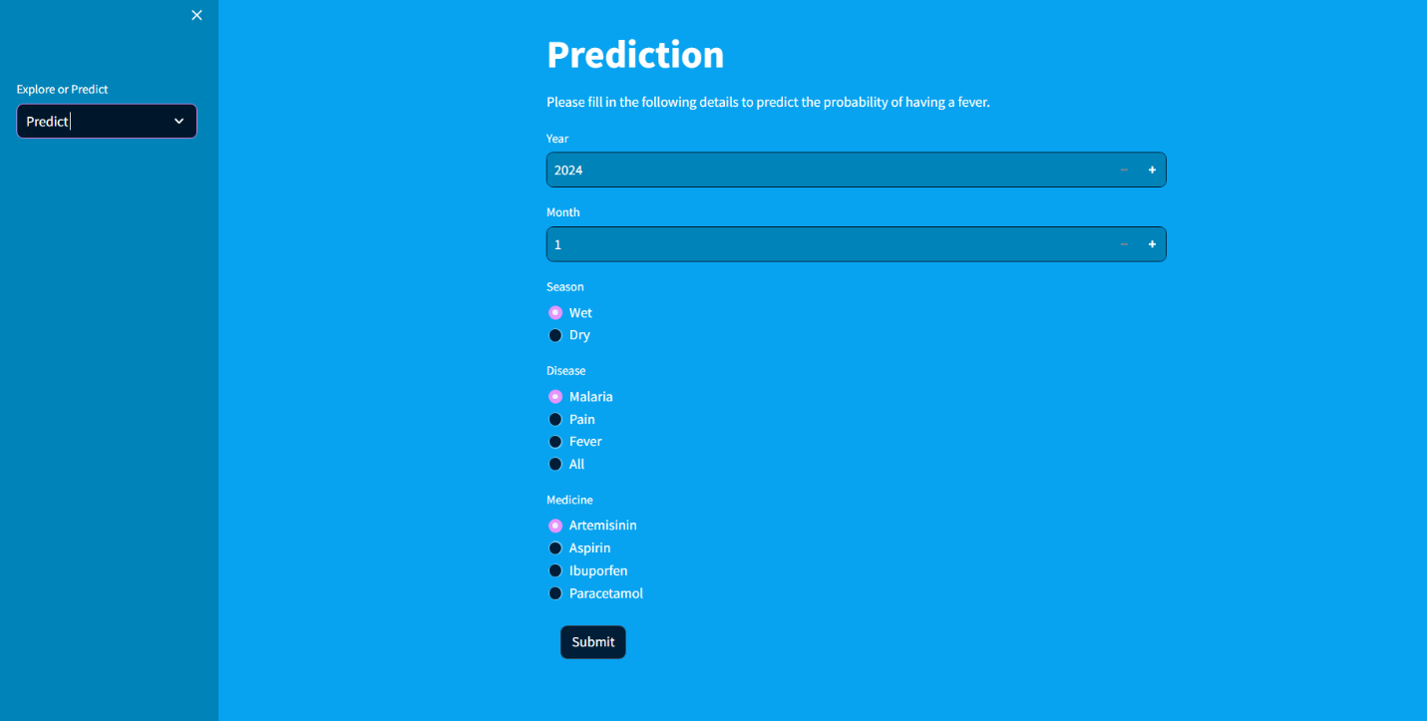
* The UI has an interface where the user can view the historical values in form of graph.

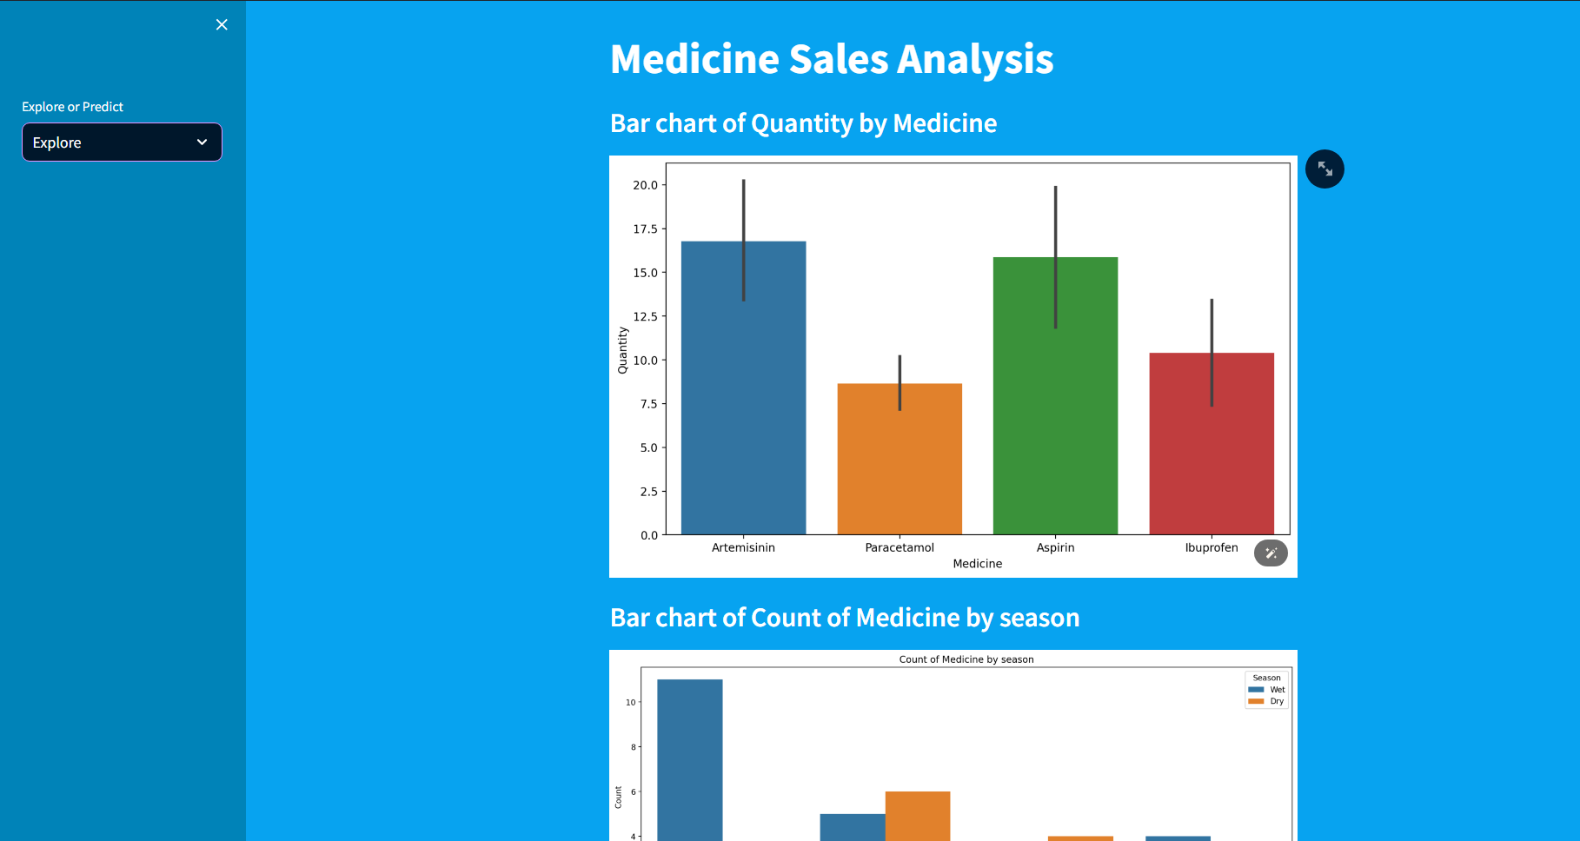

* 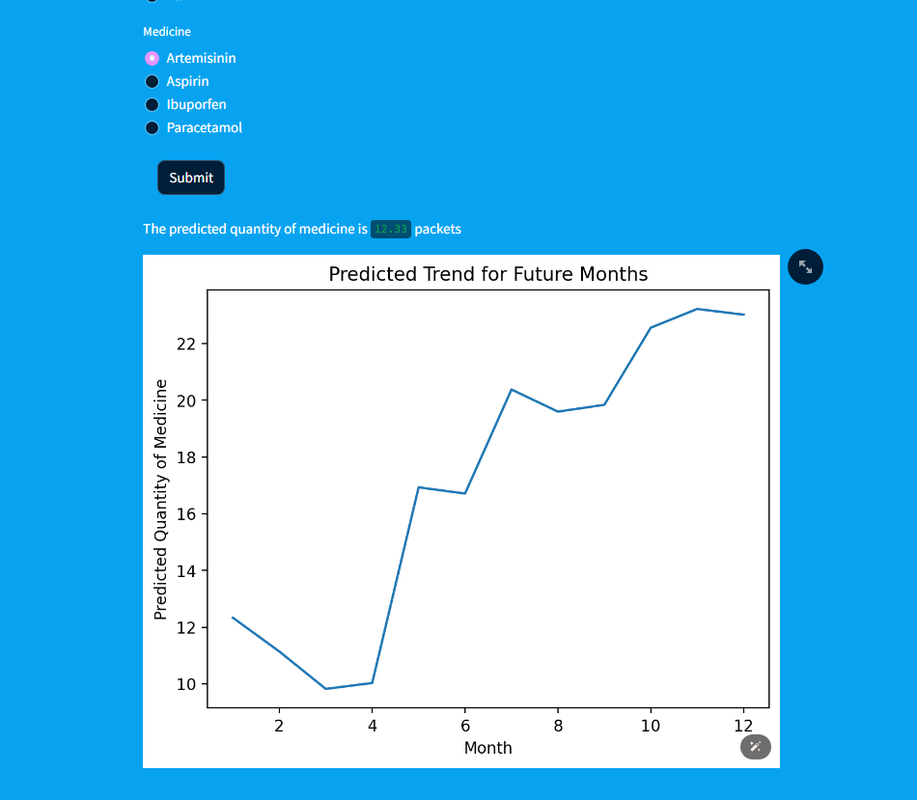**Machine Learning Models:** Employ machine learning models to predict user intent and responses. These models can range from rule-based systems. In this instance the user is going to input the needed value and based on that we get the results.
* 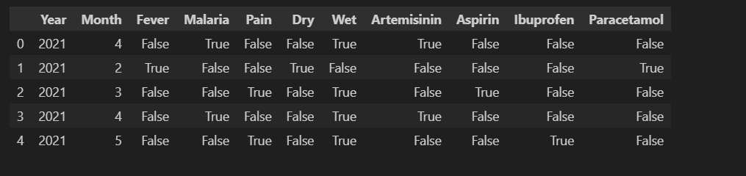Train the models on a dataset of historical interactions to improve accuracy over time.
* 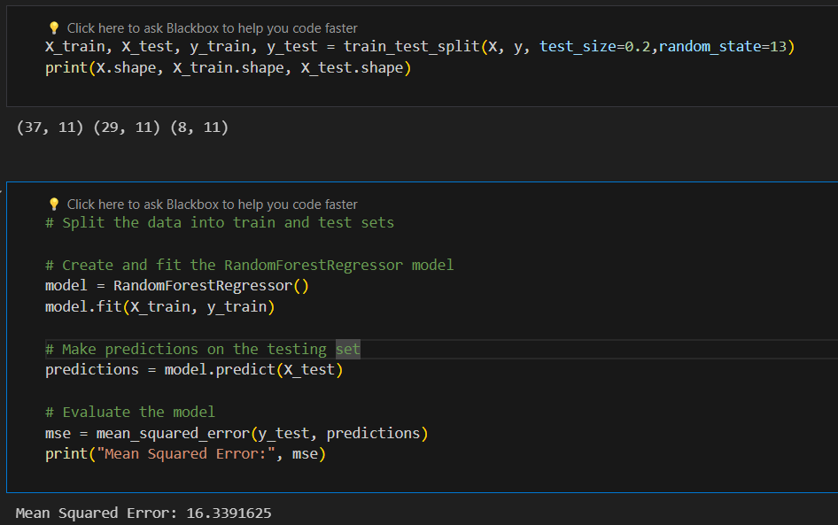Utilize techniques regression using machine learning algorithms, The Model used for training the data is random forest regressor, as it gave the most consistent and accurate result.

**Predictive Analytics:**

* + Utilize predictive analytics techniques to anticipate user needs and provide proactive assistance.

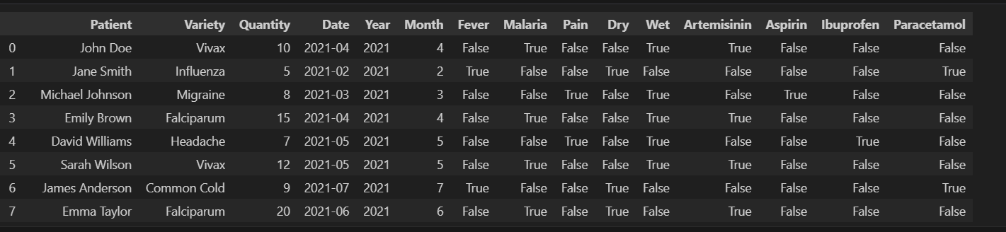

* + 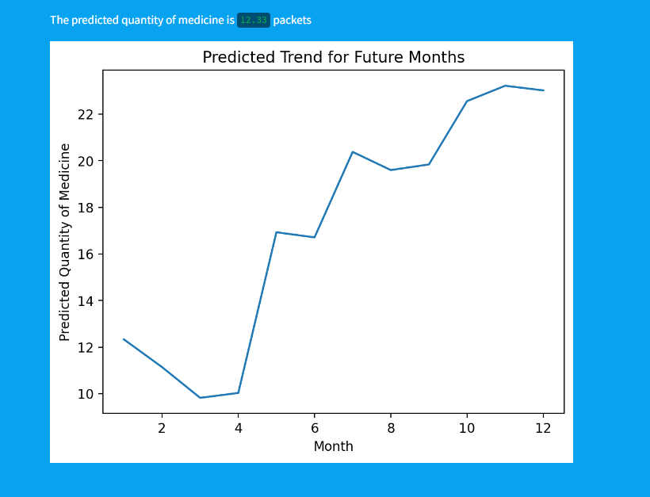Analyze historical data to identify patterns and trends, enabling the to make informed predictions about the data.